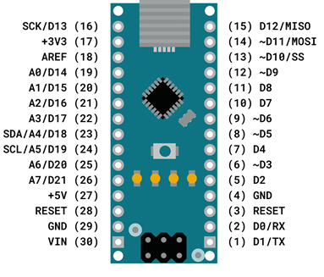
Name and GPIO no | Role | Nano pin no | Role | used | Pico pin  no | Pico GP no
int Transmit = D1: | // Transmit pin | 1 | Out
int Receive = D0; | // Receive pin | 2 | In
Reset |  | 3 | In
Gnd |  | 4
int m1encoder1 = D2; | // motor 1 encoder 1 input interrupt pin | 5 | In
int m2encoder1 =D3; | // motor 2 encoder 1 input interrupt pin | 6 | In
int m1encoder2 = D4; | // motor 1 encoder 2 input | 7 | In
int m2encoder2 = D5; | // motor 2 encoder 2 input | 8 | In
int sensorLED1 = D6; | // 1st diagnostic LED on sensor board | 9 | Out
int lmotorDIR = D7; | // Left motor dirn input 1 | 10 | Out | x | 10 | GP7
int rmotorDIR = D8; | // Right motor dirn input 3 | 11 | Out | x | 11 | GP8
int lmotorPWM = D9; | // Left motor PWM pin | 12 | Out | x | 12 | GP9
int rmotorPWM = D10; | // Right motor PWM pin | 13 | Out | x | 14 | GP10
int sensorLED2 = D11; | // 2nd diagnostic LED on sensor board | 14 | Out
int trigger = D12; | // trigger for sensor LEDs | 15 | Out | x
int LED13 = D13; | // ext LED Red | 16 | Out | x | 26 | GP20
+3.3V | Regulated down from Vin | 17 | Out | x | 36
Aref |  | 18 | In
int lside = A0; | // left side sensor input | 19 | In
int rfront = A1; | //front left line sensor input | 20 | In | x | 31 | GP26
int lfront = A2; | //front right left sensor input | 21 | In | x | 32 | GP27
int rside = A3; | // right side sensor input | 22 | In
int sens1 = A4; | // unassigned sensor input 1 | 23 | In
int sens2 = A5; | // unassigned sensor input 2 | 24 | In
int fourwayswitch = A6; | // input from function switch | 25 | In
int battery = A7; | // input for battery measurement | 26 | In | 2.5v
+5V | Regulated down from Vin | 27 | Out |  | 39
RESET |  | 28 | In
GND |  | 29 |  |  | 38
Vin 7 to 12V | Now 5v from regulator | 30 | In |  | 39
Regulator output | 5.17v
Battery voltage | 7.38

